Report for Monte Carlo Simulation

Yang Zhenze

2015K8009915023

Physics

Introduction

Methods

Results

Discussion

Reference

**Introduction**

Monte Carlo Methods are widely useful categories of computational algorithms that depends on the sampling with random moves to obtain numerical outcomes.

The vital principle of the algorithm is using a Markov Chain to calculate the average of the states that observe Boltzmann Distribution.

In statistical physics, the partition function is calculated by the integration in the phase space considering both coordinates and moments. The partition function(take canonical ensemble as an example) is as follows:



where

*pi* indicate particle momenta,

*xi* indicate particle positions,

*d*3 is a shorthand notation serving as a reminder that the *pi* and *xi* are vectors in three-dimensional space,

*H* is the classical [Hamiltonian](https://en.wikipedia.org/wiki/Hamiltonian_mechanics).

However, it is impossible to calculate multidimensional partition function so the metropolis algorithm is developed[1], the metropolis algorithm allow us to generate any average in equilibrium state that is capable of being expressed by coordinates and moments with a Boltzmann distribution.

Classic Monte Carlo Simulation is limited that it cannot get the dynamics property of a system as Molecular Dynamics Simulation does. However, there is dynamics Monte Carlo Schemes[2/48] that is able to investigate the dynamics of a specific system. As a result, it is basically alternative to choose either MC simulation and MD simulation.

**Method**

**1. System Description**

Lennard-Jones Fluid: The fluid is a kind of system with liquid-vapor coexistence. The potential of the particles in the system is determined by two types of force, one is Pauli repulsion, the other is Van der Waals interaction. The former interaction contributes to the potential function with a term ~ r-12, the latter interaction contributes to the function with a term ~ r-6, a specific form of the function is:

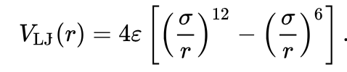

**The Figure 1** shows the plot of the function.

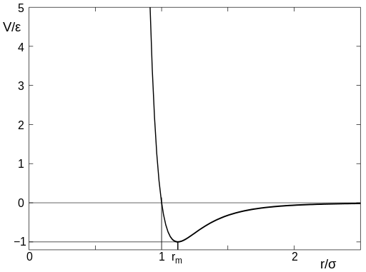

**Figure 1** The plot of the Lennard-Jones potential versus relative radium

When the density is low, the system is vapor-like. By contrast, when the density high, the system will become denser into a liquid. The transformation is capable of investigating by plotting the radial distribution function g(r). **Figure 2** is an example of the radial distribution function of Lennard-Jones Fluid at temperature=0.71 and density=0.844.

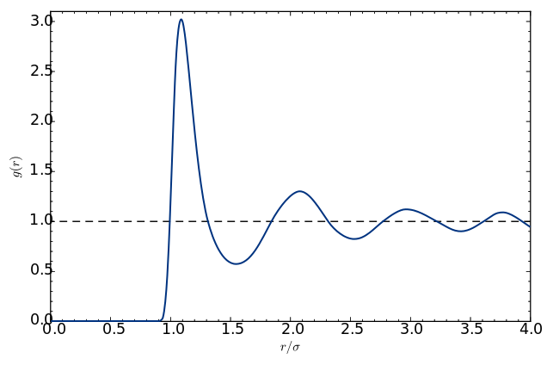

**Figure 2** The plot of the radial distribution function of Lennard-Jones fluid versus relative radium at T=0.71 and ρ=0.844

**2. Simulation Description**

In the simulation, we ignore the shape of the particles in the Lennard-Jones fluid and consider the particles as points. In order to make the simulation fast, we truncated the potential function with a linear shift.

We use Monte Carlo Simulation under constant temperature(T=1.0). We used two types of boundary conditions: HW(hard wall condition) and PBC(periodical boundary condition). The HW condition refers to a closed box that no particles can get out of the hard wall of the box. The PBC condition refers to repeating a primary box to generate an infinite system.

The variables include the number of particles(N), boundary condition(HW and PBC), density(ρ), relative radium(r/σ).

**3. Algorithm Description**

Monte Carlo Simulation: A general Monte Carlo Simulation algorithm is like this:

1.First.Define a domain of possible inputs

2.Generate inputs randomly from a probability distribution over the domain

3.Perform a deterministic computation on the inputs

4.Aggregate the results

**Initialize**: In our simulation, we set the initial configuration on the lattice point of the box. When implementing HW condition, in order to avoid sharp collision on the wall, we choose a small lattice parameter. When it comes to PBC condition, the lattice parameter we chose is relatively large to make some particles close to the boundary.

**Metropolis**: The metropolis method we used is the standard method. The random move is generated by a **random()** function. The accept ratio is determined by the Boltzmann distribution.

**Sample**: Samples of configurations are selected with a constant **sample_frequency.** In Problem 1 and 2, we calculated the average energy using **pair_energy** function with an implement of **lennard_jones_potential**. In Problem 3, we calculated the pressure **with pair_energy_gradient**. In problem 4, we collected the particles in a certain range away from a particle to count the number, thus calculating the relative density. The iterations for sample is 10000 generally.

**Truncation:** The truncation is an extremely part of the simulation. We basically utilized a linear truncation. In Problem 1a), we did the truncation right in the pairwise interaction. In other problems, we calculated the truncation by integration instead of calculating them one by one.

**4. Implement in separate problems**

**Problem 1**

(a) HW condition: reject all random move that makes the particles out of the box.

(b) PBC condition: calculate the remains of the coordinates dividing box size. Furthermore, only take the interaction between two particles whose distance is smaller than half of the box size. After doing the complementation, the particles are all in the same primary box. If the length between two particles are smaller than half of the box size, calculate their interaction. If not, because of periodicity, there will be a particle outside the box which is within the range of interaction.

**Problem 2**

The value of the cut off distance is important. Above all, it should never be larger than half of the box size. In addition, if it is too small, the force between tow particles may be extremely large.

**Problem 3**

We calculate the pressure by calculating the virial coefficient. In order to do so, it is necessary to use the **gradient function**. After sampling the pressure, it is of paramount importance to include tail correction in the final pressure.

**Problem 4**

Radial distribution function is a relative density function displaying the structure of a system. In order to calculate the function, we need to partition the box according to the radium. The number of the parts are important because it will influence the quantity of the outcome, the accuracy and the efficiency. If the partition is too small, it may not include all particles. In the simulation, we chose 100 as the partition number.

**Results**

1**.Problem 1 : <E> / N versus system size**



**Figure 3** The plot of the average potential of Lennard-Jones fluid versus number of particles at T=1.0, ρ=0.2 and rc=2.5

1.) The problem 1a) and 1b) is solves by the **Figure 3**. Since the average kinetic energy is definite, we only calculated the average potential. In addition, the speed of decreasing also decreases and it seems to become constant in the end.

2.) As the plot shows, <E>/N decreases as the number of the particles increases. It is reasonable to draw such a plot because with the increase of particles numbers(N), the number of pairwise interaction is increasing with a magnitude ~ N2. As a result, the absolute value of the average energy should increase with a magnitude ~ N. These conclusions are certainly drawn under a constant density. However, since the particles around one particular particle will stay relatively further when the closer space is totally occupied.

3.)In order to predict the result of thermodynamics limits, we have to guess the form of the function of average potential over number of particles. To realize the purpose, we can attempt to fit the curve by very simple functions. Since when N comes to infinite, the derivative of the curve becomes zero, power function and exponential function are two simplest choices. The results show that an exponential function is unable to draw such a plot. By contrast, power function basically fitted the curve well. The fitting outcome is displayed in **Figure 4**. According to the fitting, the limit of the potential should be -4.58 (energy is -3.58)which actually is lower than the true energy as we can notice the trend of the power function is much more sharp than the true curve.

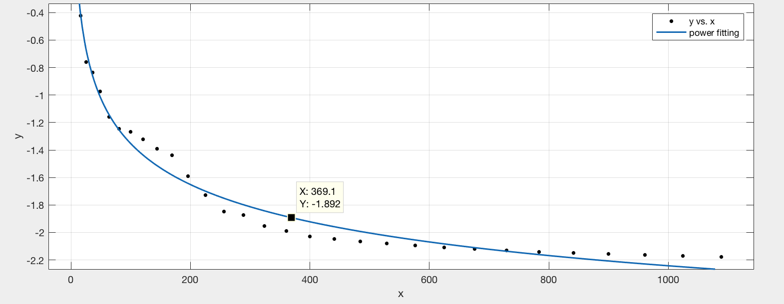

**Figure 4** The power fitting plot of the average potential of Lennard-Jones fluid versus number of particles at T=1.0, ρ=0.2 and rc =2.5(The axis is the same as Figure 3), the function is $y=6.15x^{-0.14}-4.58$

4.) Finally, from the plot, we can compare two kinds of boundary conditions, named as “HW” and “PCB”. When the number of particles is relatively small, the average energy of these two conditions is different to some extent. However, as the N goes larger, these two conditions converge which is reasonable because the interface imposes a less important impact on the property of the system.

**2.Problem 2 : <E> / N versus cut off distance(rcut)**



**Figure 5** The plot of the average potential of Lennard-Jones fluid versus cut off distance at T=1.0, ρ=0.2 and N=100

1.) When N is relatively small, the average tail correction is small in absolute value.

As the number increases, the average tail correction finally becomes stable with e = -1.4.

2.) From **Figure 4**, the average potential for N=100 is -1.27. The stable tail correction is ~ -1.4. The energy is close so the tail correction is not negligible.

3.) As for the optimized cut off distance with both accuracy and efficiency, it is obvious to notice the value lies in a range of 2.5 – 3.5(sigma). The reasons are as follows, considering the accuracy, the average potential should be stable or nearly stable, thus a larger cut off distance being better. While considering the efficiency, the smaller the distance is, the less we need to calculate. With all these considerations, 2.5σ– 3.5σ is an optimized choice for cut off distance.

**3.Problem 3: pressure versus density**



**Figure 6** The plot of the average pressure of Lennard-Jones fluid versus density at T=1.0 , ρ=0.2 and N=484

1.) As for the liquid-crystal transition, from my point view, there ought to be a large increase in pressure. With such consideration, the critical density for the transition is between 0.7 and 0.8

2.) The trend is generally the same as the result shown in our textbook[3] when T=0.9 and N=500. There is even a negative pressure generated when density increases. The reason is that in a finite system, a relatively important free-energy cost is associated with the creation of a liquid-vapor interface. So much so that, for sufficiently small system, it is favorable for the system not to phase separate at all[4].

**4.Problem 4: radial distribution function versus density**

**(a)**

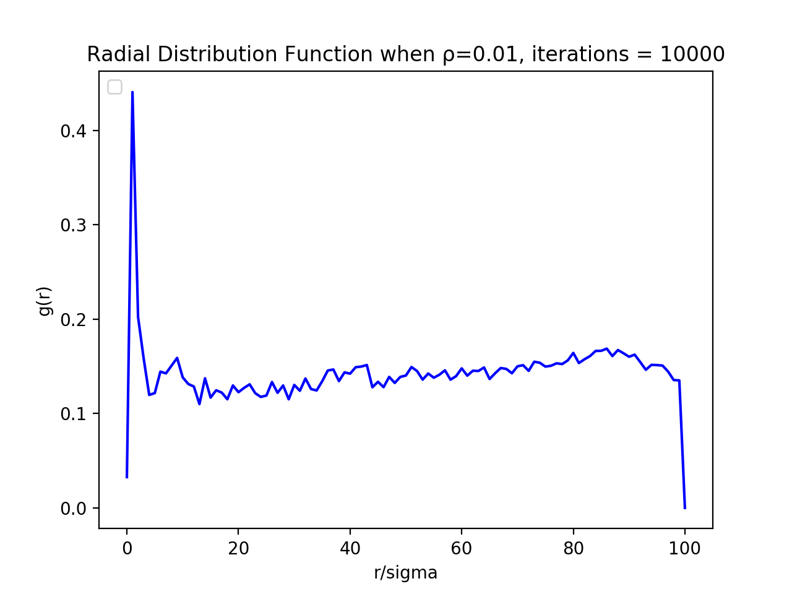

**(b)**

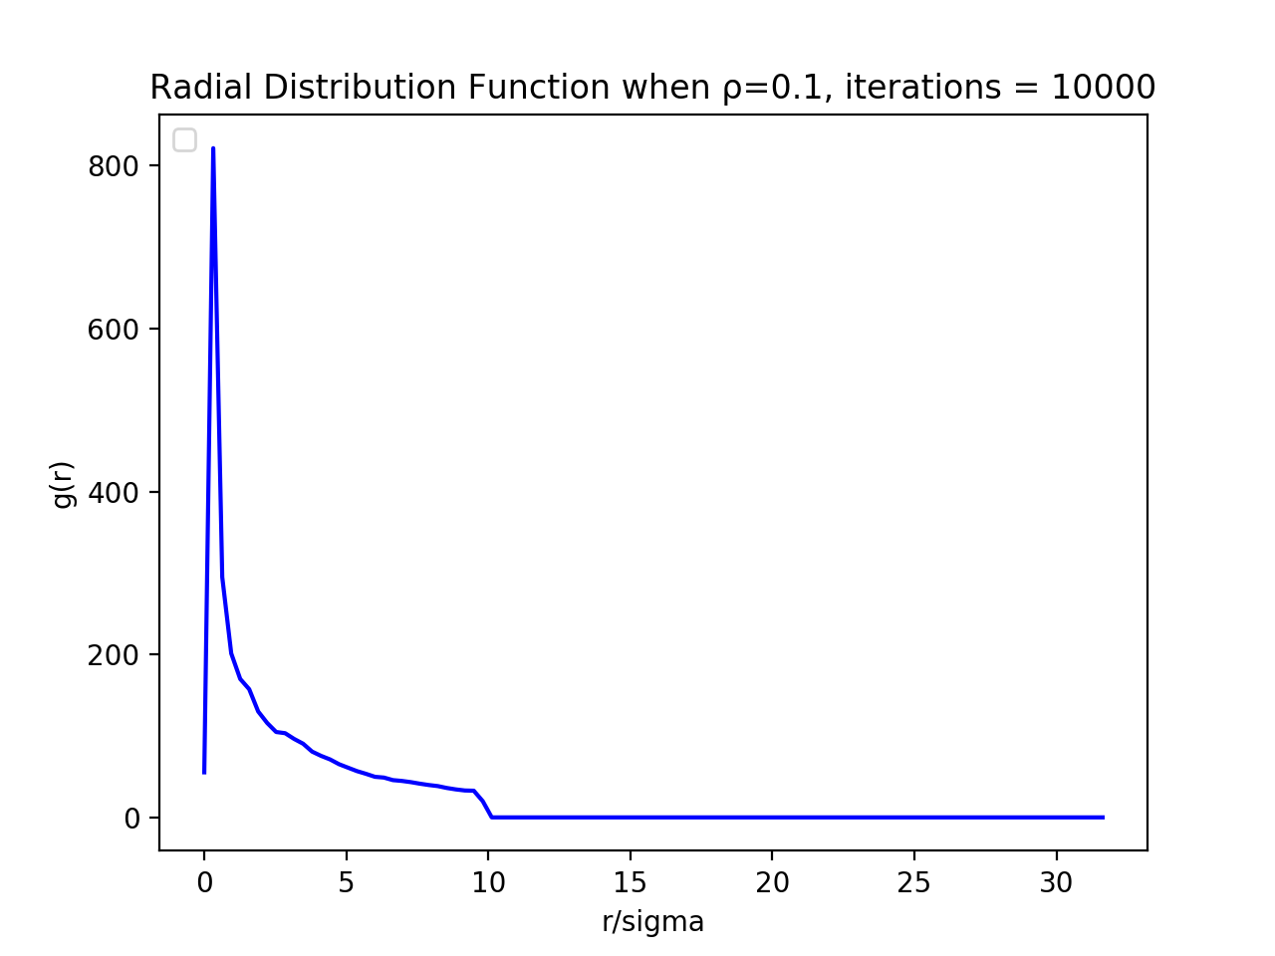

**(c)**

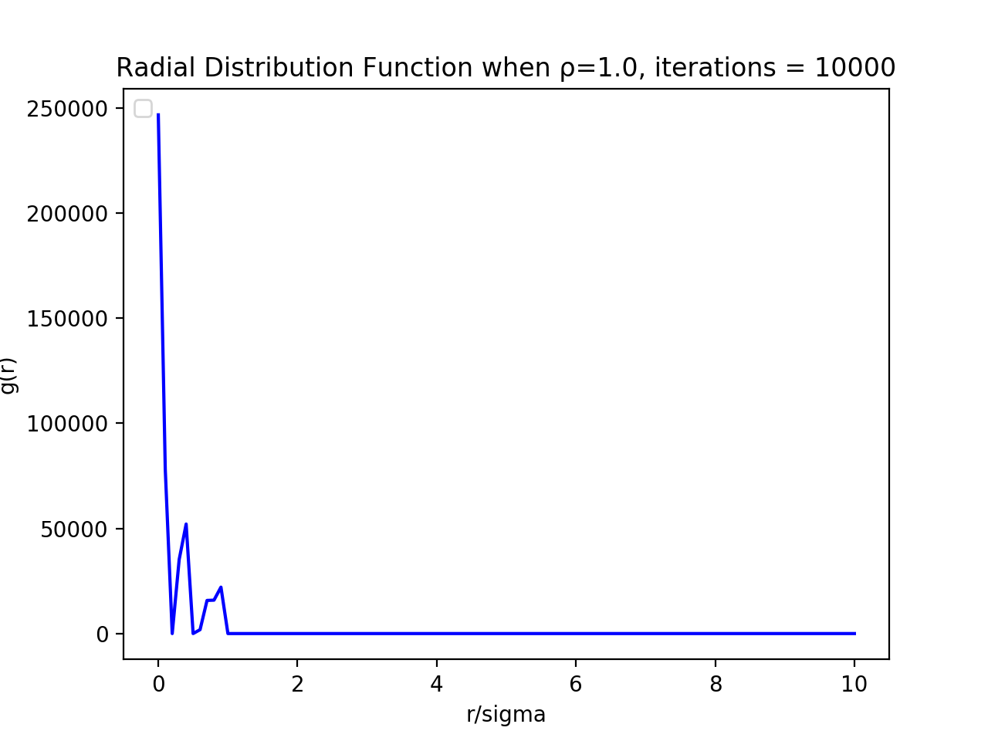

**(d)**

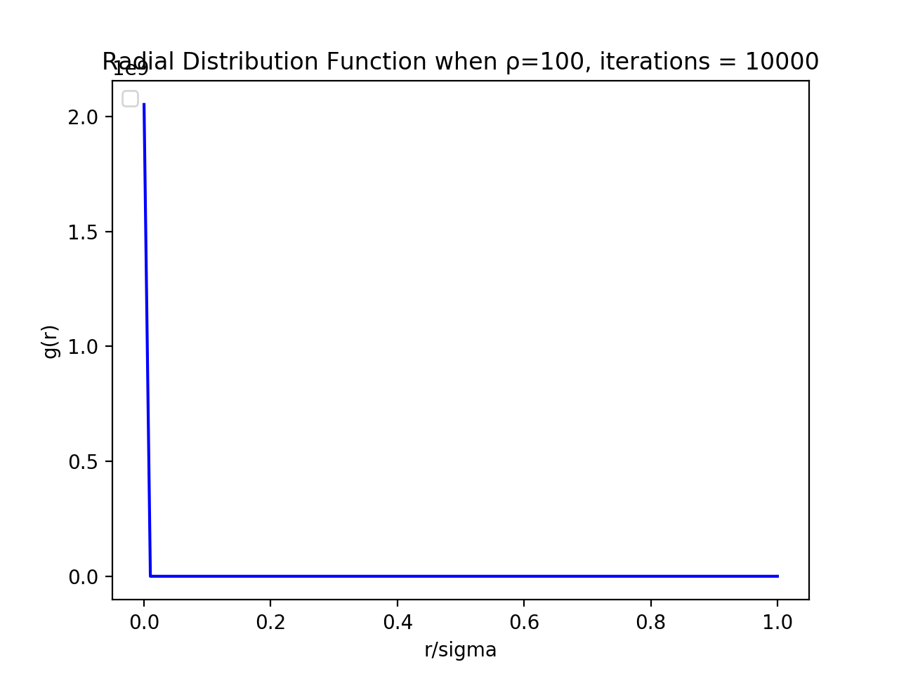

**Figure 7** The plot of the radial distribution function of Lennard-Jones fluid versus r/sigma at T=1.0 , rc=2.5 and N=400 after 10000 iterations with different densities: (a)ρ=0.01,(b)ρ=0.1

(c)ρ=1.0,(d) ρ=100

1.) As we can notice from the plot, with the density increasing, the g(r) becomes

more and more narrow. The reason is simple that when the density rises, the system becomes much more condense.

2.) When ρ=0.01, after the first peak, the g(r) becomes approximately constant and the value is not zero. The condition is similar as that in ideal gas, though the g(r) is not always 1. Because most particles condense closely to the center, the g(r) is diluted when it increases.

3.)When ρ=0.1 or 1.0, the g(r) reflects that the system is in liquid state(or liquid-vapor state, liquid-crystal state). When ρ=1.0, the g(r) is like a **Dirac Comb**, which is actually a crystal-like structure because the crystal’s g(r) is a combination of Dirac function.

4.) When ρ=100, the g(r) condenses to one point. It means when we partition the box in 100 parts, the particles are all condensed in the part that is closest to the center. If we enlarge the number of parts, it will probably show a crystal’s g(r).

**Discussion**

**1.Impact of initial configuration**

In the simulation, we found that a good initial configuration will lead to a save of iterations. The initialization is carried by positing the particles in the lattice. The size of the lattice should be smaller than the size of box. By varying the lattice constant, we are able to speed up the simulation.

Generally speaking, it is a better choice to choose an initial configuration close to the equilibrium[3].

First, when the density increases, choosing a smaller lattice constant to posit the particles is better. The magnitude of iterations to get the expected outcome is 100 when choosing half of the box size as the length of the whole lattice positing the initial particles. By contrast, the magnitude of iterations is 10000 when the lattice is nearly the same shape of the box.

Second, in a low density, such as 0.2, it is better to posit the particles close to the wall when using periodical boundary condition rather than the hard wall condition.

Because the hard wall will inhibit the move of particles. However, the particles running out of the box will increase the time of calculation.

**2. Iteration impact**

Iterations are relatively important parameters in the simulation because it determines the accuracy and efficiency of the simulation. By investigating the iterations, we can even reveal the process that a system falls into an equilibrium.

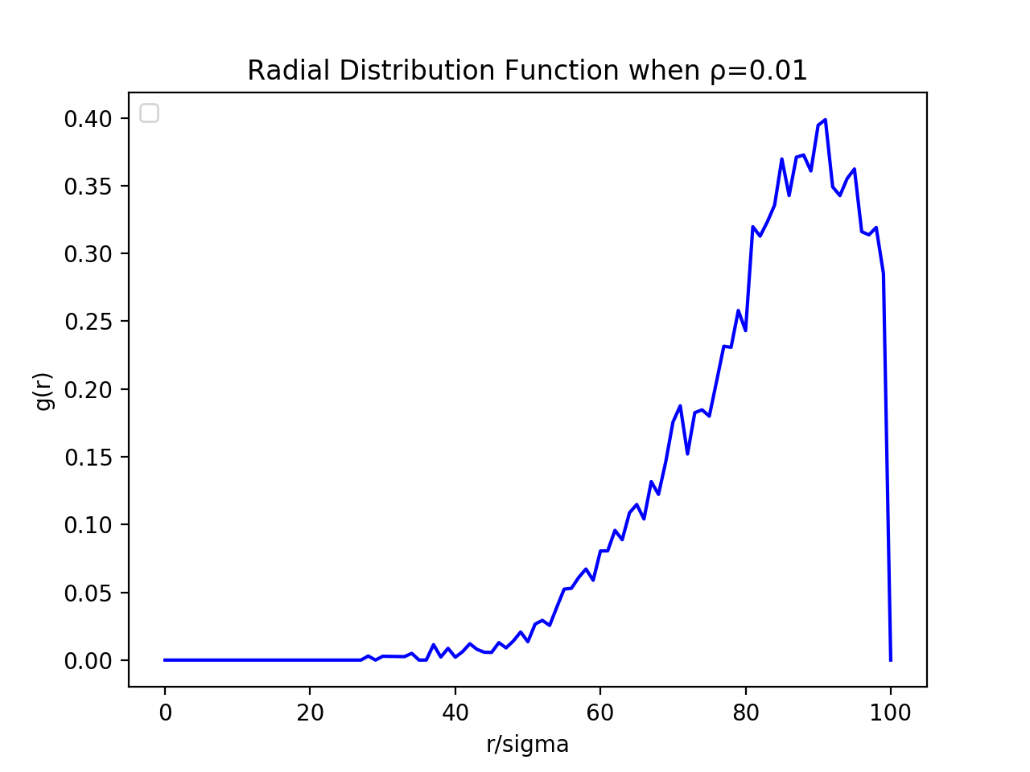

**Figure 8** The plot of the radial distribution function of Lennard-Jones fluid versus r/sigma at T=1.0 , rc=2.5 , N=400 ) and ρ=0.01 after 1000 iterations

The **Figure 8** displays the g(r) of the system after 1000 iterations. The particles are not distributed evenly, the state is probably a metastable state. The proof is when the step size becomes small, this plot is more likely to show up. In addition, when the initial configuration varies, the metastable state may not be reached.

**Reference**

[1]Hastings, W.K. (1970). "Monte Carlo Sampling Methods Using Markov Chains and Their Applications". Biometrika. 57 (1): 97–109.

[2] K.A. Fichthorn and W.H. Weinberg. Theoretical foundations of dynamical

Monte Carlo simulations. J. Chem. Phys., 95:1090–1096, 1991.

[3] Daan Frenkel, Berend Smit-Understanding Molecular Simulation

[4] Z.W. Salsburg and W.W. Wood. Equation of state of classical hard spheres at

high density. J. Chem. Phys., 37:798–804, 1962.

**Other Sources**

Tao Pang An Introduction to Computational Physics-Cambridge University Press (2006)

<https://en.wikipedia.org/wiki/Main_Page>